LEAGUE T-SHIRT ORDER FORM
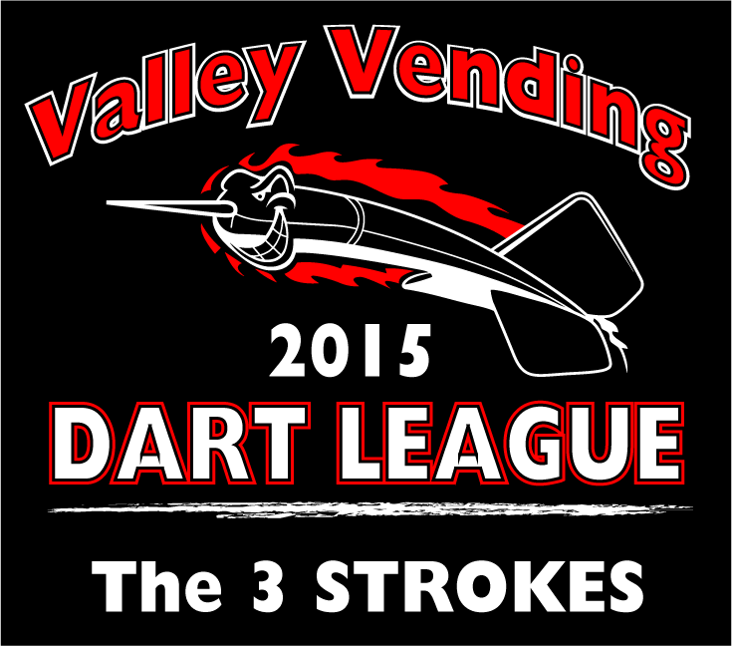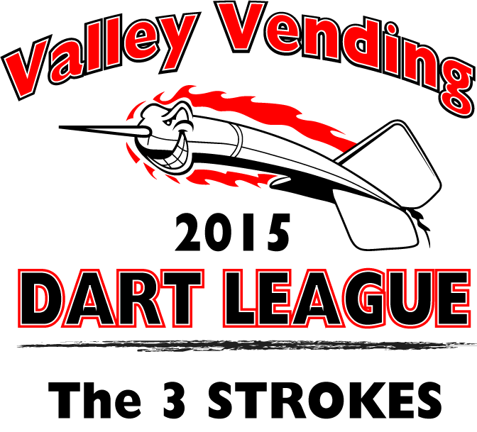
ASH GREY
BLACK
CHARCOAL
FOREST GREEN
LIGHT BLUE
MAROON
NAVY
ORANGE
RED
ROYAL
SAFETY GREEN
SAFETY ORANGE
SAND
SPORT GREY
WHITE

SIZE CHART
S, M, L, XL
XXL + $1
XXXL + $2
$11.00 PER SHIRT with pocket
ADD
$2.50 FOR PLAYER NICK NAME
ON FRONT
Your team name goes in place of “the 3 strokes”

PLEASE PRINT CLEARLY ON FORM BELOW

TEAM NAME: ____________________________________________________

COLOR (CIRCLE ON CHART ALSO): _____________________
(LEAVE NAME BLANK IF NONE DESIRED ON FRONT OF TEE)

NAME: _____________________________ SIZE: _________COST $__________

NAME: _____________________________ SIZE: _________COST $__________

NAME: _____________________________ SIZE: _________COST $__________

NAME: _____________________________ SIZE: _________COST $__________

NAME: _____________________________ SIZE: _________COST $__________

NAME: _____________________________ SIZE: _________COST $__________

SUB TOTAL__________
LEAGUE (CIRCLE ONE) TAX___________ CRICKET Tuesday NORTH SOUTH GRAND TOTAL___________

