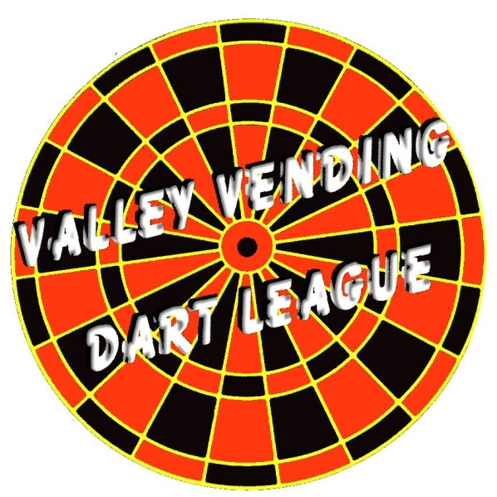

ADIRONDACK LEAGUE

League Sponsors and Players:

Deadline for fall league entries is September 21st. Roster forms must be turned in to Valley Vending by this date. League dues for the season will remain at $16.00 per week, per team ($4.00 per person). A Valley Vending sanctioning fee of $6.00 per player will be due with roster forms. The sanction fee for substitutes may be paid with the roster form or after the player plays in his/her first match.
Roster forms cannot be accepted without sanction fees.

MONDAY NIGHT: Handicapped Cricket League:

The league consists of up to 8 players per team (4 starters, 4 substitutes) and plays 13 games per night. There is a Marks per Round (MPR) cap of 10.50 for the top 4 players per team. New players in the league will receive an average MPR of 1.8. The Captains meeting will be on Monday, September 28th, at Cobble Hill, 7:00pm. We will be looking for a few volunteers to be on the league committee.

If you have any questions, please contact Shane Kelley @ Valley Vending, 561-0300 or e-mail shane@valleyvending.com.

